## Spinach package – basis selection guidelines

This document provides some practical advice on the choice of basis sets for Spinach calculations. Using incomplete basis sets requires detailed understanding of the spin dynamics in the system. Therefore, unless you know precisely what you are doing, it is a good idea to select bas.mode=’complete’ – this option corresponds to running the formally exact simulation. Spinach would still run much faster than any other time-domain Liouville space code. With large spin systems, however, we would not have that option, therefore...

1. **State space restriction**

As the picture below demonstrates, some simulation trajectories never populate the entire state space of the spin system, and it is therefore possible to run exact simulations at a much reduced computational cost in a suitably restricted basis (see our recent publications in the *published_papers* directory for further details). Spinach would run simulations in any basis you set, the key question is about the size (=quality) of it.

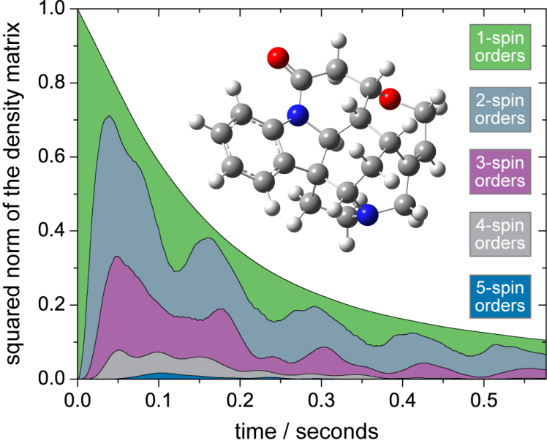

Figure . Numerical simulation of the density matrix norm dynamics during the evolution and detection period of a pulse-acquire NMR experiment on the 22-spin system of strychnine. All distances and magnetic parameters imported from a GIAO DFT B3LYP/EPR-II calculation. Bloch-Redfield-Wangsness relaxation superoperator (including DD, CSA and cross-correlation terms) was used with isotropic rotational diffusion correlation time of 200 ps.

In the example above, state space restriction to five-spin orders would produce accurate results, and a basis set such as IK-1(5,3) – state space restriction to five-spin orders between directly coupled spins and to three-spin orders for all spins within 4 Angstroms of each other – would be an appropriate choice. Systems where spin-spin couplings are stronger and more numerous would require a larger basis set: in ESR and solid state NMR systems it is not uncommon to see 8-spin and higher orders populated.

Just like it happens in Quantum Chemistry, the responsibility for choosing the correct restricted basis rests with the user: for example, a doubles-restricted basis set is unlikely to be accurate, and including ten-spin orders for a liquid state NMR system is likely to be a computationally expensive overkill.

The following equation provides an estimate of the minimal basis set requirements:



where  gives the maximum correlation rank to be included in the basis,  is the target accuracy,  is the average relaxation rate in the system and  is the average coupling. Running the analytics.m function to produce the plot of the kind shown in Figure 1 is always a good idea – research literature comparing the performance of different basis sets in different settings has yet to emerge.

The table below contains the list of the restricted basis sets that Spinach supports out of the box. Use the bas.manual option to set up your own basis.

**Table 1.** Basis set specification syntax in *Spinach* –parameter summary for basis.m function.

|  |  |  |
| --- | --- | --- |
| **Parameter** | **Values** | **Comments** |
| bas.mode | ‘*complete’*  *‘IK-0’*  *‘IK-1’*  *‘IK-2’*  *‘ESR-1’*  *‘ESR-2’*  (default is ‘*IK-2*’) | ‘*complete*’ generates the complete basis set;  ‘*IK-0’* includes all product states up to order bas.level between all spins;  ‘*IK-1*’ includes all product states up to order bas.level between directly coupled spins and up to order bas.space_level between spins that are closer together than tols.prox_cutoff. Liquid-state simulations use the scalar coupling network to generate this basis and solid-state simulations use all couplings, including the traceless ones.  ‘*IK-2’* includes, for every spin, the spin orders involving all directly coupled spins and up to order bas.space_level between spins that are closer together than tols.prox_cutoff. Liquid-state simulations use the scalar coupling network to generate this basis and solid-state simulations use all couplings, including the traceless ones.  *‘ESR-1’* generates the complete state space for all electrons and includes the identity and  states for each nucleus. This is often a good choice for simple high-field ESR experiments.  *‘ESR-2’* generates the complete state space for all electrons and all anisotropically coupled nuclei, but only includes the identity and  states for isotropically coupled nuclei. This is often a good choice for complicated high-field ESR experiments. |
| bas.level | positive integer  (default is 4) | Defines maximum subgraph size for ACS (all connected subgraphs) partitioning of the coupling network. Relevant for IK-0 and IK-1 basis sets. |
| bas.space_level | positive integer  (default is 2) | Defines maximum subgraph size for ACS (all connected subgraphs) partitioning of the spatial proximity network. Relevant for IK-1 and IK-2 basis sets. |
| bas.cnes | 1 or 0  (default is 0) | Flag requesting the inclusion of IK-2 states into the basis. CNES stands for “coupling neighbourhood of every spin”. Relevant for IK-1 basis set. |
| bas.manual | (*m* × *nspins*)  logical matrix  (default is empty) | A list of *m* spin sets (defined by the user as logical row vectors with *1* in the position of the included spins and zeros elsewhere)to be added to the list of subgraphs of the coupling graph. This triggers the inclusion of the complete state space of the chosen spin subsystems into the basis. |

1. **Symmetry factorization**

A simulation that starts in a particular symmetry state and evolves under the Hamiltonian that conserves that symmetry would never populate states of different symmetries. This is recognized by the Spinach kernel, which supports spin permutation symmetries. The following groups are supported:

S2, Ci, C2, Cs, S3, C3v, D3, S4, Td, S5, S6, D2h

along with their direct products. All spin quantum numbers are supported. The following example declares three groups of equivalent spins, each related by C3v symmetry, the first one incorporating spins 14, 15, 16, the second one spins 17, 18, 19 and the third one spins 20, 21, 22.

sys.sym_group={'C3v','C3v','C3v'};

sys.sym_spins={[14 15 16],[17 18 19],[20 21 22]};

Although all irreducible representations are commonly populated in Hilbert space simulations, in Liouville space only the fully symmetric irreducible representation is often active (see our JCP paper from 2010 for explanation). Accordingly, Spinach defaults to projecting the system into the fully symmetric irrep. Processing of other irreps may be forced by setting sys.sym_a1g_only=0.

It is important to note that the symmetry factorization described above is operating *in spin space* – all interaction tensors of symmetry-related spins must be identical in orientation as well as magnitude.

1. **Conservation law screening**

It is often the case that the coherence order is conserved (exactly or approximately) during the dynamical process. Spinach offers an option to screen the basis sets according to coherence order and only keep the user-specified coherences. The following statement:

bas.projections=[-1 0 1];

causes coherences of order –1, 0 and 1 to be kept in the basis. Coherence order is defined as the sum of the projection quantum numbers of all single-spin irreducible spherical tensor operators entering the direct product state.

1. **Trajectory-level state space restriction**

The Path Tracing (PT), Zero Track Elimination (ZTE) and Destination State Screening (DSS) procedures are described in detail on our papers (JMR 2008, JCP 2010, JMR 2011). With the default tolerances, these procedures are essentially exact and are applied transparently and automatically every time the Spinach time evolution module is called. For debugging purposes they can be disabled by setting

sys.disable={‘pt’,’zte’,’dss’};

(this would often result in a dramatic slowdown).

1. **Basis indexing conventions**

Many Spinach functions operate semi-analytically by taking advantage of the irreducible spherical tensor rank information contained in the basis descriptor array. Understanding how basis set information is stored is critical in understanding much of Spinach kernel – see the Spinach paper.